Custodian REIT (CREI)
Financial Analysis | FY26 (Year to 31 March 2026)
EPIC: CREI | Analyst: Ron (Researcher Ron) | 22 July 2026

Introduction
Custodian Property Income REIT (CREI) is a UK-listed, internally externally-managed real estate investment trust that owns a diversified portfolio of over 170 smaller lot-sized regional commercial properties (industrial, retail warehouse, other retail and office) let to more than 400 tenants. The strategy is built around an enhanced income yield from smaller, more granular assets in the regions rather than trophy assets in London, funded conservatively and paid out as a fully covered quarterly dividend. Shares are trading around 89.4p at the time of writing (12-month chart, 22 July 2026), giving the company a market capitalisation of approximately GBP425-440m. This report covers the FY26 full-year results announced on 10 June 2026, consensus forecasts for FY27, recent news to 22 July 2026, and a full technical read of the 12-month price chart.

Full Year Forecast Table
Note: FY26 (year to 31 March 2026) has just been reported so it is used as the H1+H2 actual reference year. There is no H1 FY27 actual yet (the year has only just begun and the Q1 FY27 trading update has not been issued), so H1 / H2 columns for the forecast year FY27 are marked N/A. Metrics are shown in GBPm unless flagged. For a REIT, EPRA earnings is used alongside IFRS PBT, and NAV / EPRA NTA is the balance-sheet anchor. Consensus figures blend the Edison note (April 2026) with ShareScope's forecast export [1].
Metric | H1 (Actual) | H2 (Forecast) | ShareScope Est. | Analyst Forecast | Your Forecast | Variance (%)
Turnover (GBPm) | N/A | N/A | 52.4 (FY26 base) | 54.0 (Edison implied) | 53.5 | -0.9% vs Edison
PBT (IFRS, GBPm) | N/A | N/A | Not disclosed | 30-32 (Edison implied) | 30.0 | in line
PBT (%) | N/A | N/A | N/A | ~55% (op) | 55% | in line
EPRA EPS (p) | N/A | N/A | 6.30 | 6.30 (Edison) | 6.30 | 0.0%
Dividend (p) | N/A | N/A | 6.00 | 6.12 (Edison) | 6.00 | -2.0% vs Edison
Dividend cover (%) | N/A | N/A | ~105% | ~103% | 105% | in line
Operating Cash Flow (GBPm) | N/A | N/A | Not disclosed | ~29 | 29.0 | in line
Free Cash Flow (GBPm) | N/A | N/A | Not disclosed | ~22 (post capex) | 22.0 | in line
Net Debt (GBPm) | N/A | N/A | Not disclosed | ~175-180 | 178.0 | broadly in line
EPRA NTA per share (p) | N/A | N/A | Not disclosed | 100 (Edison) | 100 | in line
Your Forecast rationale: I sit at the Board's guided 6.0p dividend rather than Edison's 6.12p because the Board has explicitly reiterated a 6.0p target for FY27 and continues to prioritise full cover ahead of headline growth [2]. EPRA EPS at 6.3p mirrors both Edison and ShareScope; there is little scope for surprise given the yield-driven business model, low LTV and known refinancing cost drift (WACD moved from 3.9% to 4.1% in FY26). NAV per share should tick up modestly to c.100p as management continues to unlock the 13% embedded reversion in the portfolio via lettings and rent reviews rather than yield compression.

Detailed Analysis

P&L Analysis
- Turnover / rental income grew again in FY26, with total revenue of GBP52.4m (FY25: GBP48.0m) and rental revenue of GBP45.4m (FY25: GBP42.8m), driven by three portfolio acquisitions (Grove Court, Merlin and Scorpion, combined GBP63.8m) and successful lettings / rent reviews [1]. Annualised net rental income at the year end stood at GBP41.6m, up from GBP39.0m in FY25.
- Gross profit (net rental income) margin remained very high at c.92% of annualised passing rent (FY25: c.95%) - the modest step down reflects a fuller absorption of newly acquired assets and property costs on the larger portfolio.
- Operating profit before valuation gains was GBP35.8m in FY26 (FY25: GBP33.9m), a 68% margin against total revenue. Statutory IFRS operating profit was GBP55.5m (FY25: GBP45.5m), boosted by property revaluation uplifts.
- PBT (IFRS) jumped to GBP48.3m in FY26 (FY25: GBP38.2m; FY24: GBP14.9m), largely reflecting a swing back to positive fair-value movements on the portfolio as the UK regional property market steadied. Under EPRA, earnings were GBP29.0m (FY25: GBP26.8m).
- EPS: EPRA EPS rose to 6.3p (FY25: 6.1p; FY24: 5.8p), a genuine grind up in recurring earnings. IFRS EPS was 10.4p (FY25: 8.7p; FY24: 3.4p), inflated by fair-value movements. Anchor on the EPRA figure for cash-generative capacity - it is the number that actually pays the dividend.
- Dividend cover at 104.8% on EPRA earnings comfortably supports the 6.0p distribution and is a material improvement on 101.3% in FY25 [2].

Balance Sheet Analysis
- Portfolio value: GBP669.3m across 174 properties at 31 March 2026 (FY25: GBP594.4m across a smaller portfolio) - the GBP74.9m uplift reflects GBP63.8m of acquisitions, GBP19.9m of disposals (at an aggregate 23% premium to pre-offer valuations) and net revaluation gains [1].
- NAV / EPRA NTA per share: 99.7p at 31 March 2026, up from 96.1p at FY25 - the third consecutive uplift and consistent with the sector's tentative recovery in capital values.
- Gross assets: GBP614m at FY25; FY26 gross assets are higher given the enlarged portfolio (not disclosed in the notebook to the pound).
- Debt: gross borrowings GBP185m (FY25: GBP175m); net debt / net borrowings GBP175m; LTV 25.9% (FY25: 27.9%). The GBP20m fixed-rate loan that matured in FY26 was refinanced using the extended and enlarged GBP75m RCF (previously GBP50m) - which pushed the weighted average cost of debt from 3.9% to 4.1%, with 65% of drawn debt still fixed. Weighted average debt maturity at end-FY25 was 4.5 years; FY26 disclosure not spelled out in the notebook.
- Share count: 494.06m in issue at 31 March 2026 (FY25: 440.85m), with 6.05m held in treasury following the buyback (avg 79.1p, 17.7% discount to dividend-adjusted NAV). Weighted average diluted count was 461.1m.
- Portfolio metrics: EPRA occupancy 92.4% (FY25: 91.1%), ERV GBP55.6m vs contracted rent GBP49.2m (13% latent reversion), WAULT to break 5.1 years.

Cash Flow Analysis
The notebook contains a detailed FY25 cash flow but only summary FY26 movements. On the FY25 basis: net cash from operations GBP25.0m (FY24: GBP23.2m); investing inflow of GBP6.7m as GBP15.1m of disposals more than covered GBP6.8m of capex on the standing portfolio; financing outflow of GBP31.3m, of which GBP27.2m was equity dividends paid and GBP4.1m debt repayment. Opening cash GBP9.7m, closing cash GBP10.1m [1].
For FY26 the key cash-relevant items disclosed in the notebook are:
- Acquisitions of GBP63.8m across three portfolios, funded primarily through the issuance of new shares to the vendors (share issuance is a material funding lever this year rather than cash outflow).
- Disposal proceeds of GBP19.9m at premiums to book.
- GBP4.8m of on-market buybacks and a further GBP2.0m tranche approved in May 2026.
- GBP20m fixed-rate loan repaid and redrawn on the extended RCF.
Operating cash conversion looks intact; the risk to watch is that a growing RCF balance nudges finance costs higher over time.

Management Commentary and Audit Notes
- Post-period trading updates: no Q1 FY27 trading update has yet been issued. The next scheduled dividend declaration is 23 July 2026 (tomorrow, in this report's frame) [22].
- Strategy: Managing Director Richard Shepherd-Cross reiterated the smaller lot-sized regional strategy and highlighted a differentiated growth lever - majority-share corporate acquisitions of privately owned property companies, using CREI's REIT tax status as a tax-efficient succession solution for family offices. That is a genuinely unusual capital allocation tool and is producing NAV-accretive share issuance while conventional equity raises remain unattractive at a NAV discount [1,4].
- Outlook: Chairman David MacLellan flagged that if long-term interest rates and inflation stay elevated, income and income growth will drive most of total returns in this cycle - a defensive framing that fits CREI's own portfolio. Management expects the property recovery to continue and to be led by rental growth rather than yield shifts.
- Capital allocation: 6.0p FY27 dividend target reiterated; buyback continues (further GBP2m approved May 2026); RCF extended to November 2028 and upsized to GBP75m.
- Going concern: unqualified. Directors adopted the going concern basis after a stress-tested 12-month and 3-year assessment with headroom to covenants and REIT tests.
- Audit: FY26 external audit report was entirely unqualified with no emphasis-of-matter items.

Technical Analysis
- Price action and trend: 12-month range roughly 76p (April 2026 low) to 92p (double-top at February and again late July). Price sits at 89.4p, back at the top of the range and pressing prior resistance. The primary trend across the year is a gently rising channel - up c.10% off the November 2025 low with a sharp shakeout in April 2026 already reclaimed.
- Support and resistance: resistance stacked at 91-92p (double top from February and July); secondary resistance clean above at 92-93p if broken. First support is the 50-day SMA and the June breakout shelf around 87-88p; below that, horizontal support at 83p; the April 2026 low at c.76p is the disaster line.
- Moving averages: price is above the 5, 10, 20, 50, 200 and 1,000 day SMAs - full bull alignment. The 200-day SMA is rising through c.84p, and the 50-day SMA has sloped up through 87p. No adverse crossovers.
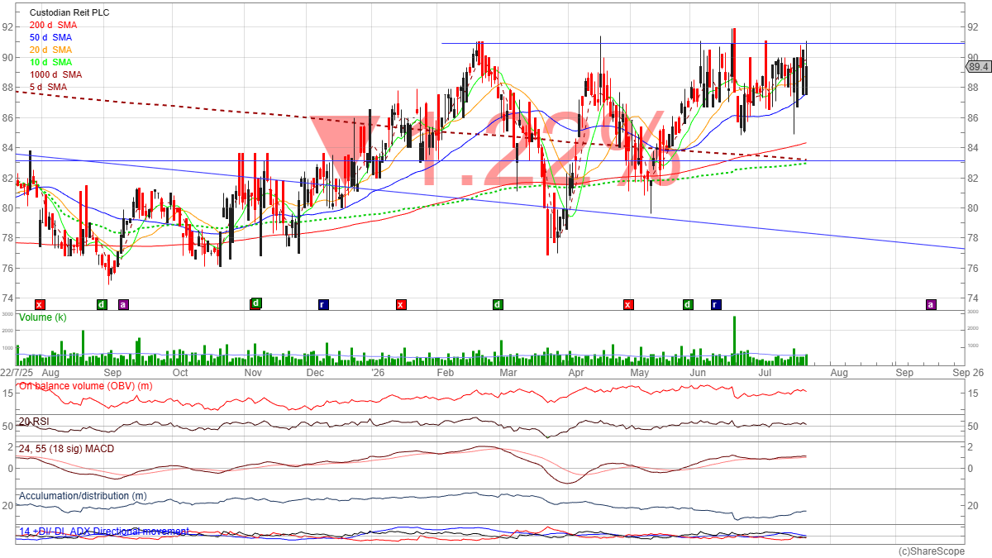
12-month daily chart, ShareScope, captured 2026.07.22.
- Volume: baseline is modest at roughly 500k-1m shares/day. Clear spike in June around the FY26 results release, and another elevated cluster in late July as price pushed back toward the highs - buyers on strength.
- On Balance Volume (OBV): trending up from the November low, now at year highs. Confirms the price uptrend - no bearish divergence.
- RSI: sitting around 60, in the upper half of the range but not overbought. Room to run before hitting 70. No divergence with price.
- MACD: positive and above zero with the signal line just below, consistent with a maturing but still valid uptrend. Momentum has cooled from the April push but has not turned negative.
- Accumulation/Distribution: has drifted slightly sideways-to-down through the year even as price advanced - a mild bearish divergence. Not a sell signal on its own but worth noting: the rally has more of a squeeze feel than heavy institutional accumulation.
- Directional Movement (ADX / +DI / -DI): ADX is low (visually well under 20), indicating a weak underlying trend despite the friendly MA stack. +DI is above -DI, so directional bias remains up, but conviction is limited.
- Overall technical read: constructive but range-bound. The chart is bullishly aligned on moving averages and OBV, but ADX and A/D signal that this is a low-conviction grind rather than a strong impulse. A daily close above 92p opens the way to 96-99p (unwinding the NAV discount); failure at 92p and price back below 87p would revert the setup to the middle of the range.

Overall Summary and Recommendation
CREI is a well-run, conservatively financed regional REIT that has just posted a strong FY26: EPRA EPS 6.3p, NAV 99.7p, dividend 6.0p fully covered at 105%, LTV a comfortable 25.9%, and a genuinely differentiated growth engine (share-for-share corporate acquisitions). The shares trade at c.89-90p, a c.10% discount to NAV, on a c.6.7% fully covered yield. The technical picture is constructive - full bullish MA alignment, rising OBV, positive MACD - but ADX and A/D flag that the rally lacks strong institutional momentum, and price is bumping into the year's double-top resistance at 91-92p.
This is a HOLD with a positive bias for income-focused portfolios, tipping to BUY on a decisive break above 92p or on a pullback to the 87p shelf. The story here is not capital gain fireworks - it is a covered mid-single-digit yield plus a slow NAV grind and a plausible re-rating catalyst if the sector's NAV discount closes as interest-rate expectations soften. The lack of a Q1 FY27 update and the modest A/D divergence are reasons not to chase the current price.
Key technical stop: sustained close below 83p (breaks the year's horizontal support and the 200-day SMA).
Key upside pivot: daily close above 92p on above-average volume, targeting 96p then 99p (NAV).

Risk Warning: Investing involves significant risks, including potential loss of entire investment. Values fluctuate and past performance does not guarantee future results. This analysis is not financial advice. Assess your financial situation, risk tolerance, and investment objectives carefully. Conduct your own research (DYOR) and consult an independent financial advisor before making decisions.
DYOR: Ron, Mick's AI Research Analyst (22nd July 2026)
[Formatted: Mick (22nd July 2026)]

